Supply Chain Management (SCM)
Week 8 · Session 1: SC Network Optimization — Facility Selection & Break-Even Analysis
1. Module Context — Analytics in Supply Chain
- Currently in Module 3: Analytics in SC
- Data availability has increased → analytics now critical for SC decisions
- This week: focus on Supply Chain Network Optimization
- Role of facilities in SC design
- How facility decisions affect customer demand fulfillment

★ SC Network Design = Strategic + Long-Term decision. Requires extensive planning.
2. SC Network Design — Objective & Key Trade-offs
- Objective: minimize SC cost, improve service levels, fulfill customer demand optimally

Efficient vs Responsive — Quick Recap
- Efficient SC: fewer facilities, larger in size
- Responsive SC: more facilities, smaller in size
- Key question: How many? And where? → this is the network optimization problem

3. Factors Affecting Facility Location
- Demand: volume, frequency, customer location — quantified from market data
- Suppliers: type, location, availability of suppliers for your product
- Logistics Infrastructure: existing roads, ports, rail — affects viability of location
- Labour: availability & cost of workforce at that location
- Regulations / Tax Benefits: government incentives change over time — must be factored in
- Other: social, political, geographical reasons

- Facilities in SC can be: manufacturing plant, warehouse, distribution center, retailer, etc.

★ Location of facilities determines HOW products move through the SC to fulfill customer demand.

4. Three Major Decisions in SC Network Optimization
- ① Facility Selection Decision — choose best from existing/available options
- ② Facility Location Decision — find exact location for a new facility given supply/demand constraints
- ③ Complete SC Network Design — design entire network using optimization approach

- Today's focus: Facility Selection using Break-Even Analysis

5. Break-Even Analysis (BEA) — Concept
- Definition: identifies the level of activity at which a company is neither at profit nor at loss
- The point where Sales Revenue = Total Cost is the Break-Even Point (BEP)

Two Types of Cost
- Fixed Cost (FC): one-time, independent of volume
- Machinery, buildings, R&D spending, installation costs
- Does not change with quantity produced
- Variable Cost (VC): changes with volume of production
- Raw material cost, packaging, direct labour, etc.
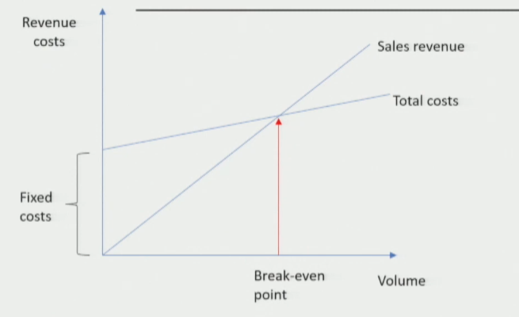

Formula

Total Cost = Fixed Cost + (Variable Cost per unit × Quantity)

BEP = Fixed Cost ÷ (Revenue per unit – Variable Cost per unit)

- BEP = volume at which company faces zero profit / zero loss

6. Case Study — Luggage Bag Company: Warehouse Location Decision
Problem Statement
- Company is launching a new bag category based on customer demand
- Estimated demand = 1,45,000 units (from market analysis)
- Must locate a warehouse to manage this new category
- Three potential locations shortlisted after initial factor analysis:

Location | City | Fixed Cost (₹) | Variable Cost (₹/unit)
X | Noida | 1,45,000 | 11
Y | Lucknow | 4,50,000 | 7
Z | Chandigarh | 7,80,000 | 6

- Goal: identify the most cost-effective location to meet demand of 1,45,000 units
7. Applying Break-Even Analysis — Step-by-Step

1 | Enter Data  Input Fixed Cost & Variable Cost for each location (X, Y, Z) in Excel
2 | Assume Volume Range  Calculate Total Cost for Q = 50,000 to 3,00,000 in steps of 50,000
3 | Calculate Total Cost  Total Cost = Fixed Cost + (Variable Cost × Quantity) — repeat for all 3 locations
4 | Plot the Graph  X-axis = Volume (units), Y-axis = Total Cost. Plot as 3 line graphs
5 | Find Intersection Points  Identify where lines cross — these are break-even quantities between locations
6 | Read Decision  For required volume (1,45,000), find which location line is lowest → that is optimal

For Location X
Q | FC | VC | Cost X
50000 | 145000 | 11 | 695000
100000 | 145000 | 11 | 1245000
150000 | 145000 | 11 | 1795000
200000 | 145000 | 11 | 2345000
250000 | 145000 | 11 | 2895000
300000 | 145000 | 11 | 3445000

For Location Y
Q | FC | VC | Cost Y
50000 | 450000 | 7 | 800000
100000 | 450000 | 7 | 1150000
150000 | 450000 | 7 | 1500000
200000 | 450000 | 7 | 1850000
250000 | 450000 | 7 | 2200000
300000 | 450000 | 7 | 2550000

For Location Z
Q | FC | VC | Cost Z
50000 | 780000 | 6 | 1080000
100000 | 780000 | 6 | 1380000
150000 | 780000 | 6 | 1680000
200000 | 780000 | 6 | 1980000
250000 | 780000 | 6 | 2280000
300000 | 780000 | 6 | 2580000

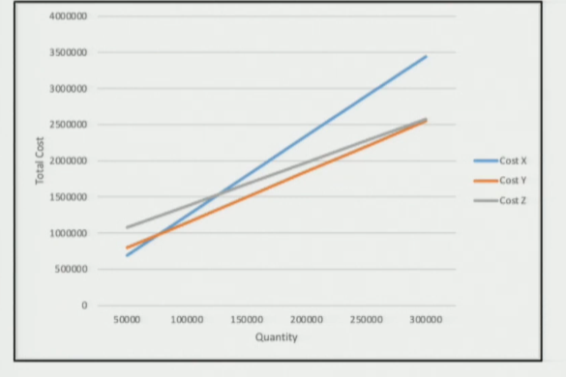
8. Result & Conclusion
- Plotted 3 cost lines (X, Y, Z) on graph — found two intersection points
- For required volume of 1,45,000 units, checked which line gives minimum cost
- At 1,45,000 units → Location Y (Lucknow) has the lowest total cost
- Decision: Warehouse at Lucknow (Y) is the most cost-effective choice

★ BEA does NOT find a new location — it selects the BEST from given options at a target volume.

Session Summary
- SC Network Optimization: strategic, long-term problem — balances cost, service level, demand fulfillment
- Facility Location Factors: demand, suppliers, logistics infra, labour, regulations, geography
- 3 Decision Types: Facility Selection | Facility Location | Full Network Design
- Break-Even Analysis: simple, widely-used method for facility selection from given alternatives
- BEP Formula: FC ÷ (Revenue/unit – VC/unit) = volume at zero profit/loss
- Case Result: Location Y (Lucknow) optimal for 1,45,000 units — lowest total cost

★ Exam Tip: BEA is used for SELECTION (choosing from options) — not for finding a new location from scratch.
★ Exam Tip: Total Cost = FC + (VC × Q). Intersection of two cost lines = break-even between those two options. Choose the location with lowest TC at target volume.

